Functional Anatomy: Light House Yoga Sculpt
Dr. Nick Alenov

12:00 – 12:15
Resources for ongoing education:
YouTube
Visible Body App
https://3dmusclelab.com/
Understanding the physical structure of the body vs. understanding body function.
What is functional anatomy?

12:15 – 1:00
Basic anatomy
Skeletal system
Anatomical position
Muscles, ligaments, tendons, fascia, joints.
Origin and Insertion: How everything connects.

1:00 – 1:30
Terminology (see flexion / extension pics below)
Movement
Neurologic tone
Introduction to RPR: How to quickly reset and restore proper tone.
Importance of proper muscular stability and tone.
Examples of injuries caused by improper tone.
Common postural issues caused by modern life.

1:30 – 2:00
A walk through the sequence

2:00 – 2:30
The anatomy of breathing

2:00 – 3:00
The importance of stretching. What stretching does and does not do.
aerobic vs anaerobic exercise
exercise at various ages (why it’s always good, and why it’s important to be safe)
Q & A

What does anatomical position look like?
There are really two anatomical positions. There is one position considered western and another considered eastern. They are more similar than different, but they do have some slight differences. In the western position, we are looking at a person standing who is facing forward, with their legs slightly apart, with arms by their sides, and their palms facing forward. In the eastern position the feet may be positioned together and the hands may be held above the head rather than by the sides of the body.
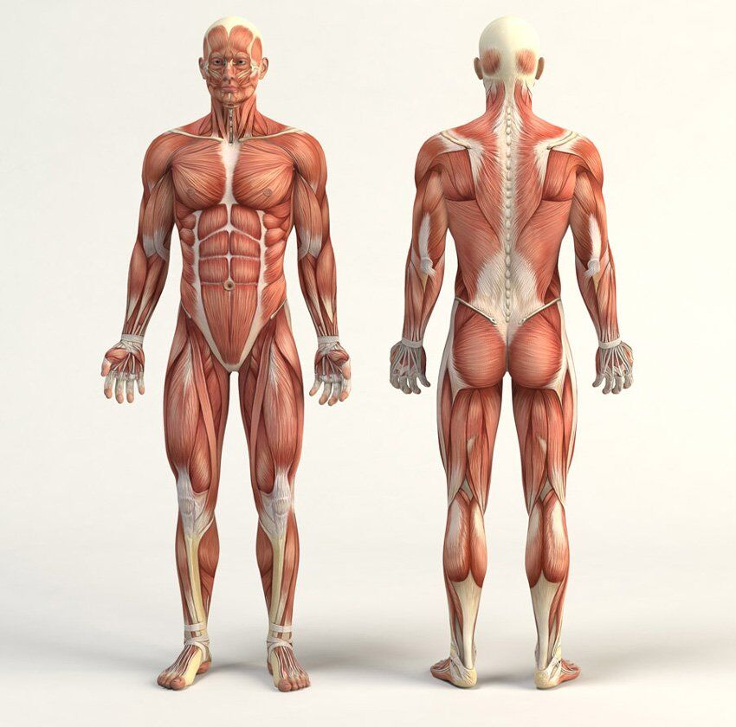

Ligament and Tendons:
Ligaments and tendons are body tissues that are essential to our movement. Ligaments are fibrous connective tissue that connect bones to bones and serve to hold structures together, while tendons are fibrous connective tissue that attach muscles to bone or other body structures.

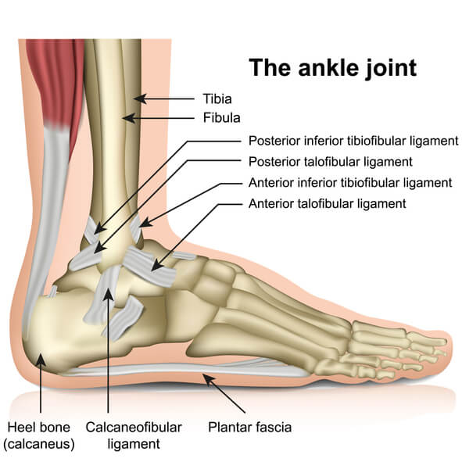

What is fascia?

Fascia is a band of thin, fibrous connective tissue that wraps around and supports every structure in your body.

Scientists initially thought fascia only provided support to your organs, muscles and bones. Recently, the definition has expanded to include the tissue that surrounds all cells, nerves, joints, tissues, tendons and ligaments throughout your body as well. As part of this discovery, they learned that fascia is a part of a system-wide network that provides form and function to every part of your body. It’s a continuous layer of tissue that’s flexible and able to resist tension.

Fascia is a stringy, white substance made mostly of collagen. Collagen is a type of protein that provides strength and flexibility. Fascia is soft, loose and made up of multiple layers. A liquid called hyaluronan is between each layer. The hyaluronan helps your fascia stretch as you move. Inflammation and trauma can dry up the hyaluronan and damage your fascia. When your fascia tightens, it can restrict the movement of your muscles and tissues, causing pain and other health conditions.

The organs have specialized names for their visceral fascia. In the brain, they are known as meninges; in the heart they are known as pericardia; in the lungs, they are known as pleurae; and in the abdomen, they are known as peritonea.

Visceral fascia also acts as a suspensory system for the organs and needs to maintain proper tone and strength. If it is too lax, it contributes to organ prolapse, yet if it is hypertonic, it restricts proper organ motility.

Muscle origin, insertion, and action:
Muscle origins and insertions describe the places where a muscle attaches to bones. Conventionally, muscle origin describes the attachment of a muscle on the more stable bone. The insertion then, is the attachment of a muscle on the more moveable bone. The action of the muscle describes what happens when the more mobile bone is brought toward the more stable bone during a muscular contraction.

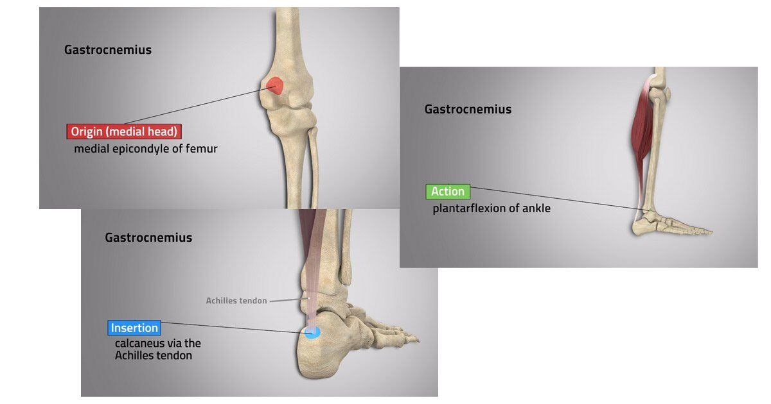

Terminology:
Flexion: Decreases the joint angle.
Extension: Increasing the joint angle.
abduction: Moving a limb away from the midline of the body.
Adduction: Moving a limb towards the midline of the body.
Medial vs. Lateral
Proximal vs. Distal

Movement 101:
As we begin to study muscles and their actions, it’s important that we don’t forget that our body functions as a whole organism. Although we learn the actions of individual muscles, in real movement, no muscle works alone. While we often have one main muscle to do an action, it is nearly always assisted in that action by other muscles. To keep things in balance in the body we also nearly always have a muscle that is assisting, resisting, or opposing any action. Let’s take a look at how we describe these relationships between muscles.

Muscle agonists
We describe the main muscle that does an action as the agonist. It is sometimes also called the “prime mover”. Many actions in the body do have one muscle that is responsible for more of the work in that action than any other muscle. For example, the agonist, or prime mover, for hip flexion would be the iliopsoas. Although it does not work alone, iliopsoas does more of the work in hip flexion than the other muscles that assist in that action.

Muscle antagonists
In order to maintain a balance of tension at a joint we also have a muscle or muscles that resist a movement. The main muscle that resists a movement is called the antagonist. We could also say that the antagonist is the main muscle that does the opposite of the action that it is resisting. For example, we could say that gluteus maximus is an antagonist of the primary hip flexor, iliopsoas because gluteus maximus is a hip extensor. Gluteus maximus is an antagonist of iliopsoas, which does hip flexion, because gluteus maximus, which does extension of the hip, resists or opposes hip flexion.

Muscle synergists
We describe muscles that work together to create a movement as synergists. For example, iliacus, psoas major, and rectus femoris all can act to flex the hip joint. There are some sections within other muscles that can also assist with flexion of the hip joint, for example, the anterior fibers of gluteus minimus and gluteus medius can assist with flexion of the hip joint, depending on the position of the hip when it’s being flexed. All of these muscles together could be referred to as synergists for flexion of the hip joint.
In real life, outside of anatomical position, we move our body in all kinds of creative and interesting ways. While we need the main muscle, or agonist, that does an action, our body has a good support system for each action by using muscle synergists. Likewise, our body has a system for maintaining the right amount of tension at a joint by balancing the work of a muscle agonist with its antagonist. Balance between a muscle agonist, its synergists, and its antagonist(s) is important for healthy movement and avoiding pain and injury.

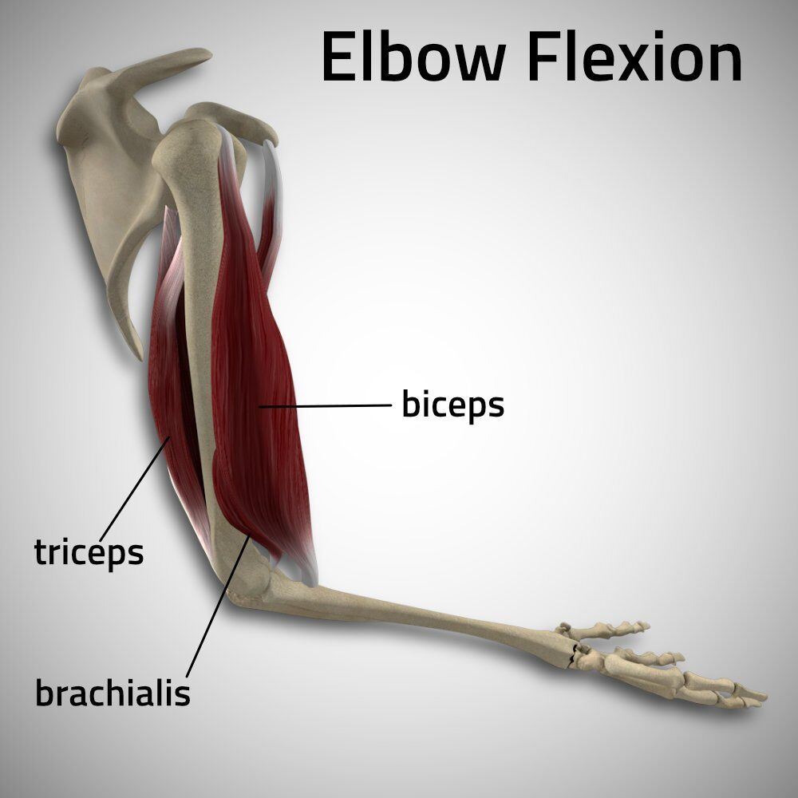

In this example the biceps are the agonist or prime mover. The Triceps is the antagonist and brachialis is a synergist with the biceps.

An introduction to RPR

RPR wake up drills: Correct sympathetic overload and reset improper gait function and muscular tone before starting an exercise or movement.

Download RPR wake up drill PDF at www.dralenov.com

A walk through the sequence:

You are doing one of three things in a pose:
- Building muscle strength.
- Activating postural support muscles and nerves (increased tone and neuro-muscular communication).
- Releasing tension in the fascia and dura.

Breathing: Anatomy, Function, Purpose
- Moving air into and out of the lungs
- Creating a constant wave of motion to the lower abdominal organs.
- Detoxification
- Creation of Chi
- Regulation of the nervous system
- Movement of energy
- Mind body connection
- Cranial Sacral movement and flow of cerebral spinal fluid

Flexion and Extension Examples:

